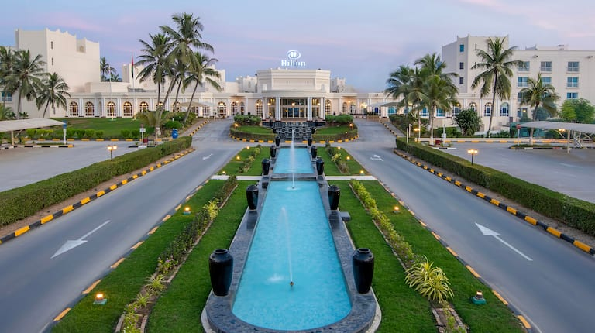

Destination: Salalah, Oman
Number of pax: 02 Adults
Travel Dates: 17th Sept’25 - 21st Sept’25
Arrival/Departure Flight: QR 1130 (2205)/ QR1131 (2310)

Itinerary:

17th Sept/Wed: Arrival in Salalah
Arrival at Muscat International Airport.
Meet our English-speaking driver & transfer to your hotel
Overnight in Rotana Salahah

18th Sept/Thurs: Classic Salalah Full Day City Tour
Start our tour with an interesting trip to the archaeological site of Al Baleed, one of the Land of Frankincense sites included on the World Heritage List. It is considered as one of the most important and oldest archaeological sites in the Sultanate of Oman. We learn about the history of the place and its prosperity in ancient times and its important role in the famous Frankincense Trail (The Land of Frankincense Museum). We will head to Al Haffa Beach, where we will come across kiosks along the road selling tropical fruits such as coconuts, bananas and sugar cane. Nearby is Al-Husn Souq, which contains various local products and goods.
Here we will find the finest types of Omani frankincense, incense, women's and men's fabrics, and handicrafts.

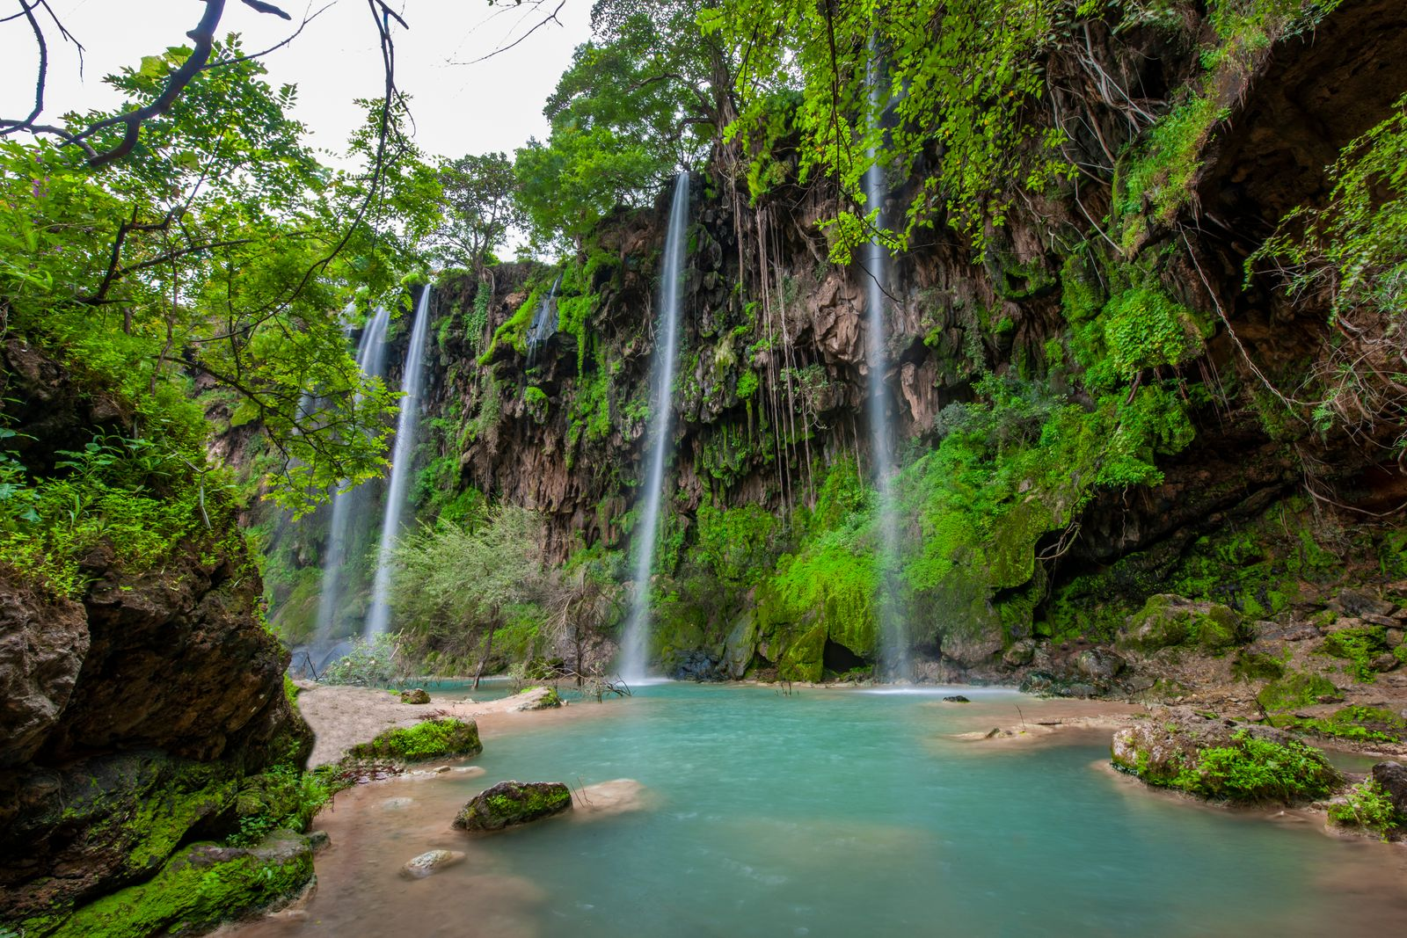

Tour Highlights:
- Museum of the Land of Frankincense
- Silver and Gold market
- Coconuts and palm's farm
- Traditional Souq
- Sultan Qaboos Mosque
Overnight in Rotana Salahah

19th Sept/Fri: East Salalah - Waterfalls Adventure (Full Day)
A scenic drive toward Taqah City, where you’ll explore the historic heritage quarter and its traditional castle. Enjoy a coffee break at Al-Askar Tower with a beautiful view over the city. Then continue to Wadi Darbat, known for its waterfalls, lakes, caves, and lush greenery. Next, visit Ayn Athum, a stunning waterfall surrounded by cliffs and thick vegetation—perfect for nature lovers. The journey continues to Jebel Samhan Plateau, offering breathtaking panoramic views over the mountains and coast, and a chance to spot wildlife in its natural habitat. This experience blends culture, nature, and incredible landscapes for a memorable day in Dhofar.

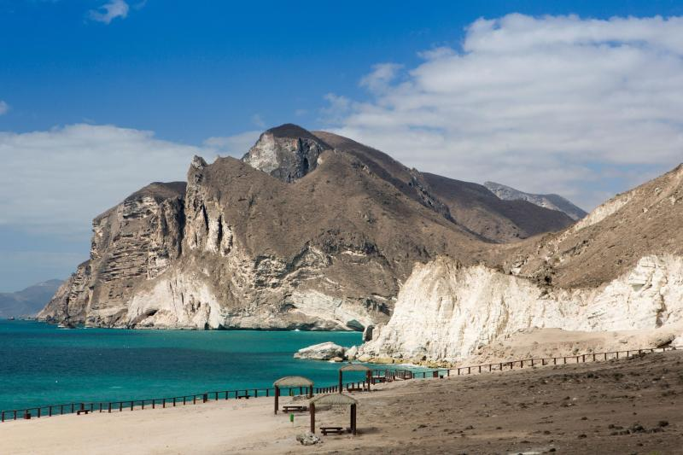

Tour Highlights:
- Al-Askar Tower, Taqah Village.
- Wadi Darbat waterfalls.
- Wadi Darbat River.
- Ayn Athum Waterfall.
- Ayn Tobrook Waterfalls.
- Taqah Plateau.
- Jebel Samhan Plateau.
Overnight in Rotana Salahah

20th Sept/Sat: West Salalah (Full Day)
Enjoy spending the most beautiful times in the west-ern regions of Dhofar Governorate, where the mountain road undulates through the towering mountains, passing through the charming beaches. Start your tour in Eftalquot area, where the charming sea view is high and overlooks the Arabian Sea among the green meadows (Al Khareef season). Then, head to Al Mughsail Beach (It was ranked by more than one international newspaper specialized in tourism among the 30 best beaches in the world), where the Marneef Cave and natural fountains are located on the western side of the beach. After about 40 kilometers away, complete your way on the western main road and enjoy the most beautiful scenery ever, until you reach the Wilayat of Rakhyut, the land of imagination. Enjoy the view of the Sha'at area, which is one of the picturesque sites unique in the beauty of nature, where you can touch the clouds and stare at the turquoise sea.
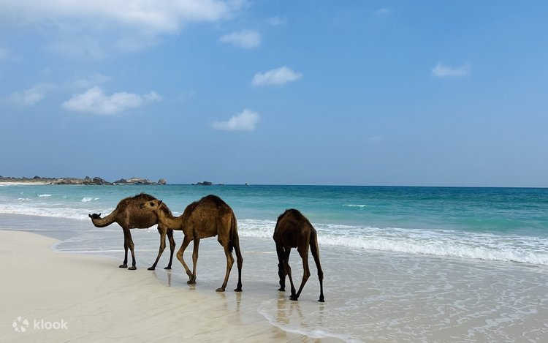

Tour Highlights:
- Mughsail Beach & Blow Holes
- Marneef Cave
- Aftalkat
- Frankincense Trees
- Shāt Plateau
Overnight in Rotana Salahah

21st Sept/Sun: Departure

Post breakfast today, check out from your hotel. Our driver will be waiting in the lobby to transfer you to Salalah Airport as per your flight timings.

End of services

Package Cost & Important Guidelines

Cost: Starting at US$ 1,050.0 per person (on single occupancy)

Inclusions:
- 3N in Rotana Salalah with breakfast on double sharing basis (classic garden room)
- Return airport transfers from SLL to the hotel in a standard car
- Full day tour Salalah East
- Full day tour Salalah West
- Half-day city tour Salalah
- Private Local English-Speaking guide for all excursions
- Entrance fees as per program

Exclusions:
- Airfare (Domestic/International)
- Visa Costs
- City Tax – to be paid on ground
- Tips for driver/guide
- Any meals not mentioned
- 5% VAT
- Alcohol
- Upgrade to All Inclusive Meal Plan

Important Guidelines:
- Rooms & Vehicles are subject to availability at the time of booking.
- All tours are on seat-in-coach basis.
- The package includes 02 full-day tours and 01 half-day tour, as described in the program.
- Services included (e.g. transport, guide, entry fees) will be listed in the program.
- Additional services will be charged separately.

